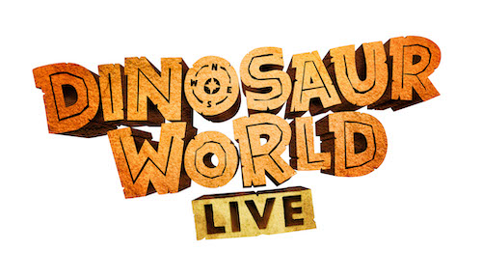

Q&A with Max Humphries, Puppet Designer

The dinosaurs were designed and created by puppet maker Max Humphries, who is known for his experimental mechanisms and novel puppet forms. Along with Dinosaur World Live, Max and his team have produced work for the National Theatre, the Royal Opera House, the Royal Ballet and many others.
We asked Max a few questions about his work on Dinosaur World Live…
What are the dinosaurs made of?
They’re made of a skeleton of very light aluminium metal. The more complex moving parts are a mix of nylon, steel, aluminium and birch. Then over that is a skin of super-lightweight foam for the muscles and then the skin is either made out of cloth or treated fur for the feathers.
How did you come up with the designs?
After agreeing which dinosaurs we were going to be making and what each were going to do, we studied the anatomy and settled on a final drawing of each dinosaur.
Then we worked out how the puppeteers would fit inside and how all the parts moved. From that I worked out the skeleton and mechanisms whilst the rest of the team worked on sculpting the outside.
Then after the outside and inside were finished we joined them together. That is why good planning is so important; everything needs to meet together.
How long did it take you to make the dinosaurs?
From the first drawings to the first show was a little over 9 months!
What was the biggest challenge in making the dinosaurs?
Keeping them light and strong. There are no electronics or hydraulics in our puppets, everything is people-powered by our great team of puppeteers, so you have to maintain a workable weight whilst also packing the most stuff into the puppets as possible.

What is most important when making puppets?
Passion and dedication to your craft.
What is your favourite part of puppetry creation and design?
Working with my team.
What is your favourite dinosaur?
Hard question, in my heart Thalassodromeus Sethi but technically she’s a pterosaur and not a dinosaur. So I’ll probably say Amargasaurus Cazaui? But in the show I think it’s probably Tamora!
Discover more at dinosaurworldlive.com

