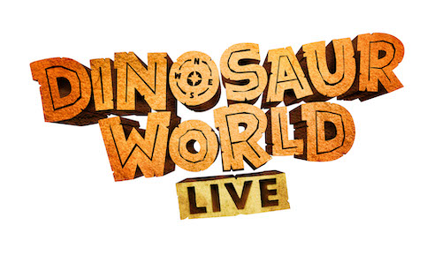

Q&A with Derek Bond, Writer & Director

Dinosaur World Live is written and directed by Derek Bond. We asked Derek a few questions about working on the show…
How would you describe Dinosaur World Live?
Miranda has grown up around dinosaurs on a far-off island, she’s brought some of her friends, and she’d love you to meet them. It’s an inspirational 50-minute interactive show with giant dinosaurs. Our biggest is nearly 10 metres long, and takes four people to puppeteer it.
What has excited you most about working on the show?
Watching the dinosaurs come to life – there’s a moment in rehearsals when the puppeteers get it right, and this collection of metal, plastic and paint is suddenly alive in front of you. That, and seeing children’s reactions when they see the show!
What qualities were you looking for when casting the show?
For Miranda, we were looking for someone who is a great storyteller, who can improvise when the dinosaurs don’t behave, and utterly believe in the puppets. For the puppeteers, strong hands and the ability to focus completely on the puppet they’re working with. It’s an amazing job – they have to make themselves disappear and allow you to totally forget they are there.
What does the typical dino rehearsal day look like?
We always start with a physical warm up – puppeteering the dinosaurs is hard physical work, and the team have to warm up like dancers or athletes do. Then we’ll look at a scene “unadorned” – that’s where the puppeteers moving around the space without the puppet, but using their hands and legs in the same way they will when they are operating the puppet. We do this because the dinosaurs are heavy, and you can’t keep stopping and thinking about what to do when someone is holding 25kg on their shoulders! When we have a shape for the scene that we’re happy with, the puppeteers will get inside the dinosaur, and we’ll test the shape out. Laura Cubitt (our brilliant puppet director) will spot the details that will help the puppeteers to make the dinosaur really “live” – it might be a breath, or a look, or a blink. After running it couple of times, we swap puppeteers – all our puppeteers can operate all the parts of each puppet, though they all have their favourites.
How do you and the puppet director, Laura Cubitt, work together?
Laura is an expert in making the puppets live, and helping the puppeteers (who might not be able to see each other) communicate and work together like they’re one living thing. I try and keep an eye on things like pacing, relationships between the dinosaurs, Miranda and the guests and what story we’re telling in each episode. Laura will translate that into movements or thoughts that are useful for the puppeteers, and offer ideas when she’s found something that the puppeteers can do with the puppet. We have to work as closely with each other as the puppeteers do!
Tell us about the audience reaction to the giant T-Rex?
It’s amazing. When Titus (our T-Rex) emerges, the audiences either jump out of their seats or hide under them! But when Miranda needs help to drive Titus back off the stage, everybody joins in. It’s a great to see children overcoming their fear and fiercely roaring at a 10m long T-Rex!
Why should people come and see Dinosaur World Live and what do you hope audiences will take away?
It’s an inspirational show – it fires the imagination and teaches you things you might not know about famous dinosaurs like T-rex and triceratops, but also introduces you to dinosaurs you might not have heard of like microraptor and segnosaurus. My hope is that audiences will come out desperate to know more about dinosaurs, and with their imaginations working on all cylinders. It’s also interactive, encouraging the whole audience to get involved.
Who do you think are easier to direct? Humans or dinosaurs?
You can tempt them with food, but if they don’t want to do something they can be really stubborn. And the dinosaurs can be hard work too.
Discover more at dinosaurworldlive.com

