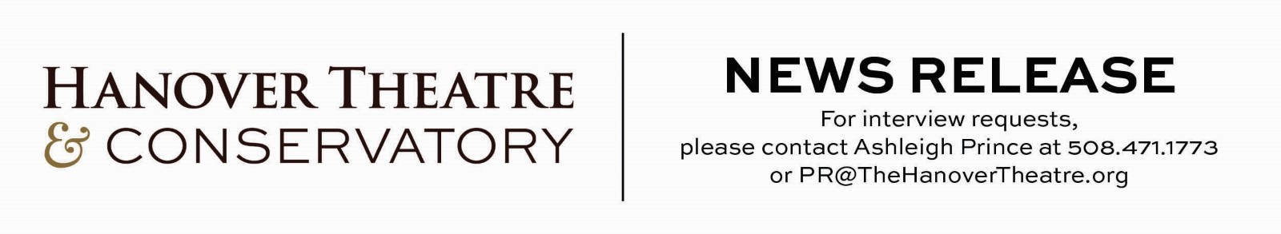
FOR IMMEDIATE RELEASE
The Hanover Theatre Celebrates the Founder of the Mighty Wurlitzer Organ - New England’s Largest Theatre Pipe Organ
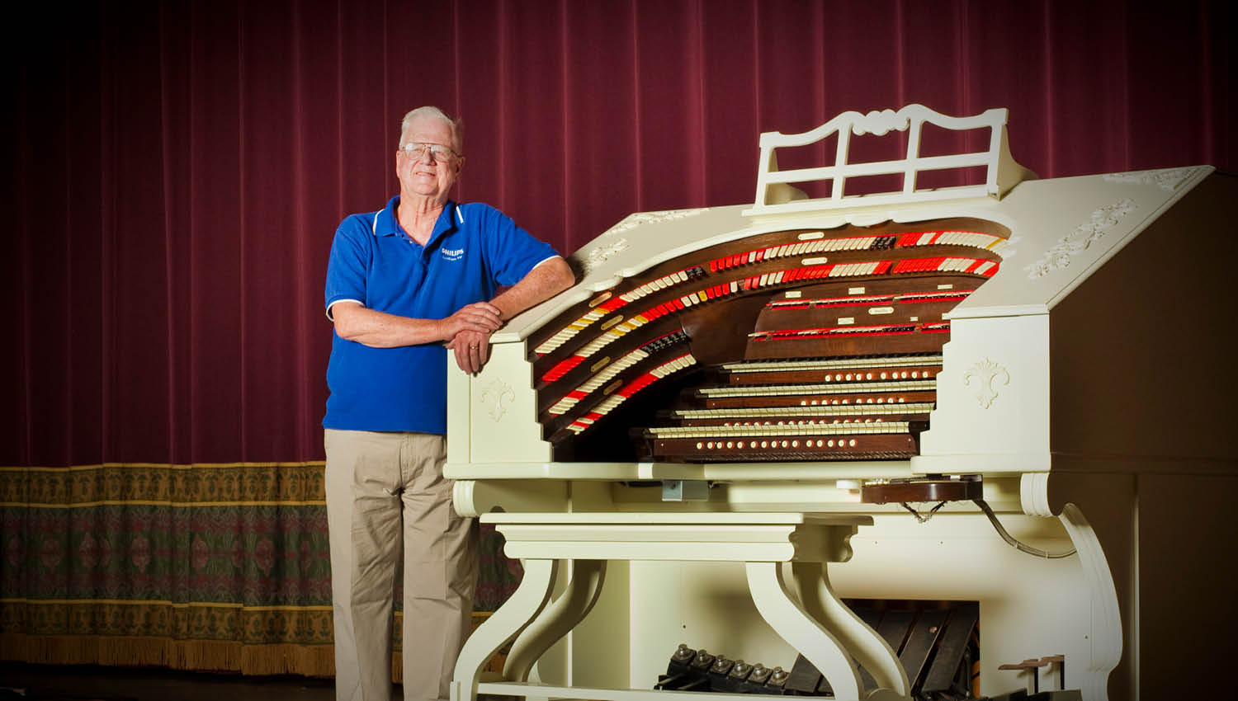
Worcester, Mass. (September 22, 2022)
Sunday, October 9, 2022 at 2:00 pm
The Hanover Theatre will be honoring Donald Phipps, founder of the theatre’s Mighty Wurlitzer Organ on Sunday, October 9, 2022, on the occasion of his 90th birthday. The special silent movie event will recognize Don’s amazing talent and immense generosity in donating the Wurlitzer Organ to the theatre.
Two short Laurel & Hardy silent movies (The Finishing Touch and Habeas Corpus) will be accompanied by the uniquely talented organist Clark Wilson, one of the most prominent and recognized scorers of silent photoplays in America today.
The event will also include a variety of Don’s favorite organ music, tributes, special guests, with birthday cake and champagne following the show.
In addition to recognizing Don Phipps’s many contributions to the organization and showcasing his impressive instrument, the event will be an opportunity to raise funds and encourage on-going support for the organ. The theatre, a 501(c)(3) non-profit organization, is committed to sharing this unique instrument and piece of cultural history with the community today and in the future.
The celebration is open to the public; general admission tickets are $20 and complimentary to patron level members. Discounts are available for subscribers, students and groups. Contact the box office at 877.571.SHOW (7469) or visit TheHanoverTheatre.org for more information.
About The Hanover Theatre and Conservatory for the Performing Arts
Since opening in 2008, The Hanover Theatre has entertained more than two million guests with Broadway musicals, comedy headliners, music, dance and more. POLLSTAR consistently ranks The Hanover Theatre as one of the top theatres in the world. The award-winning historic theatre continues to establish its place as a world-class center for the performing arts, a venue for local cultural and civic organizations and a catalyst for the revitalization of downtown Worcester. The Hanover Theatre’s facilities at 551 Main Street house function spaces, offices and The Hanover Theatre Conservatory.
The Hanover Theatre Conservatory provides performance opportunities, classes, and individual instruction in theatre, dance and technical theatre and design to more than 500 young people and adults from across central Massachusetts each year. Established in 2016, the conservatory cultivates individual attention, ignites creativity and inspires confidence through arts education led by outstanding teaching artists. The state-of-the-art facility includes classrooms, rehearsal and teaching studios, and tech and costume labs for advanced education in stage craft and design. Students receive access to master classes with national touring artists and gain professional experience from performance opportunities with THT Rep and on The Hanover Theatre’s world-class stage. THTC believes in access to arts education for all and provides financial aid for those in need. Many conservatory students have continued their pursuit of the arts at institutions such as Emerson College, Boston University, NYU, Boston Conservatory at Berklee, Berklee College of Music, Hofstra, Hartt School at the University of Hartford, Marymount Manhattan College, Syracuse University and more.
Worcester Center for Performing Arts, a registered not-for-profit 501(c)(3) organization, owns and operates The Hanover Theatre and Conservatory for the Performing Arts. All donations are tax deductible to the fullest extent allowed by law.

###

